Bootstrap 4

* Bootstrap is a front-end framework for faster and easier web development
* Bootstrap includes HTML and CSS based design templates for typography, forms, buttons, tables, navigation, modals, image carousels and many other, as well as optional JavaScript plugins
* Bootstrap also gives you the ability to easily create responsive design (Responsive web design is about creating web sites which automatically adjust themselves to look good on all devices, from small phones to large desktops)

Many users already have downloaded Bootstrap 4 from MaxCDN when visiting another site. As a result, it will be loaded from cache when they visit your site, which leads to faster loading time. Also, most CDN's will make sure that once a user requests a file from it, it will be served from the server closest to them, which also leads to faster loading time.

Bootstrap 4 use jQuery and Popper.js for JavaScript components (like modals, tooltips, popovers etc). However, if you just use the CSS part of Bootstrap, you don't need them. There are many components that requires jQuery

* Closable alerts
* Buttons and checkboxes/radio buttons for toggling states
* Carousel for slides, controls, and indicators
* Collapse for toggling content
* Dropdowns (also requires Popper.js for perfect positioning)
* Modals (open and close)
* Navbar (for collapsible menus)
* Tooltips and popovers (also requires Popper.js for perfect positioning)
* Scrollspy for scroll behavior and navigation updates

You can download and host Bootstrap 4 yourself, <https://getbootstrap.com/>, and follow the instructions there.

<!-- Latest compiled and minified CSS -->  
<link rel="stylesheet" href="https://maxcdn.bootstrapcdn.com/bootstrap/4.5.2/css/bootstrap.min.css">  
<!-- jQuery library -->  
<script src="https://ajax.googleapis.com/ajax/libs/jquery/3.5.1/jquery.min.js"></script>  
<!-- Popper JS -->  
<script src="https://cdnjs.cloudflare.com/ajax/libs/popper.js/1.16.0/umd/popper.min.js"></script>  
<!-- Latest compiled JavaScript -->  
<script src="https://maxcdn.bootstrapcdn.com/bootstrap/4.5.2/js/bootstrap.min.js"></script>

The **width=device-width** part sets the width of the page to follow the screen-width of the device (which will vary depending on the device).

The **initial-scale=1** part sets the initial zoom level when the page is first loaded by the browser.

Bootstrap requires a container to wrap the elements and there are two types of contains.

The .container class provides a responsive fixed width container

The .container-fluid class provides a full width container, spanning the entire width of the viewport

<!DOCTYPE html>  
<html lang="en">  
<head>  
  <title>Bootstrap 4 Example</title>  
  <meta charset="utf-8">  
  <meta name="viewport" content="width=device-width, initial-scale=1">  
  <link rel="stylesheet" href="https://maxcdn.bootstrapcdn.com/bootstrap/4.5.2/css/bootstrap.min.css">  
  <script src="https://ajax.googleapis.com/ajax/libs/jquery/3.5.1/jquery.min.js"></script>  
  <script src="https://cdnjs.cloudflare.com/ajax/libs/popper.js/1.16.0/umd/popper.min.js"></script>  
  <script src="https://maxcdn.bootstrapcdn.com/bootstrap/4.5.2/js/bootstrap.min.js"></script>  
</head>  
<body>  
  
<div class="container">  
  <h1>My First Bootstrap Page</h1>  
  <p>This is some bare bone of Bootstrap 4.</p>  
</div>  
  
</body>  
</html>

# Bootstrap 4 Containers

The .container class provides a responsive fixed width container

The .container-fluid class provides a full width container, spanning the entire width of the viewport

By default, containers have 15px left and right padding, with no top or bottom padding. Spacing utilities such as extra padding and margins to make them look even better. For example, .pt-3 means (padding top) "add a top padding of 16px":

<div class="container p-3 my-3 border"></div>

p-3 means 45px padding top , bottom, left , right since padding is 15px by default  
  
<div class="container p-3 my-3 bg-dark text-white"></div>  
  
<div class="container p-3 my-3 bg-primary text-white"></div>

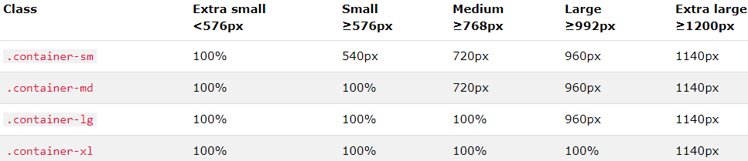

<div class="container-sm">.container-sm</div>  
<div class="container-md">.container-md</div>  
<div class="container-lg">.container-lg</div>  
<div class="container-xl">.container-xl</div>

## **Bootstrap 4 Grid System**

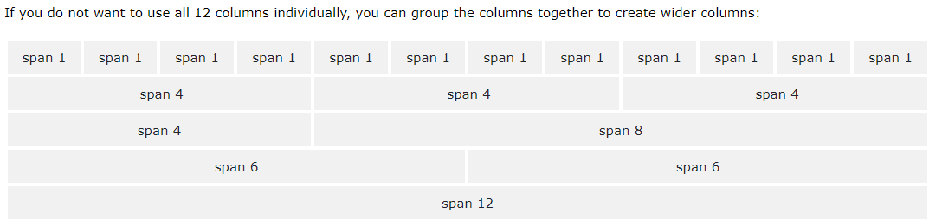

<!-- Control the column width, and how they should appear on different devices -->

<!-- The first star (*) represents the responsiveness: sm, md, lg or xl,

while the second star represents a number, which should add up to 12 for each row.-->

<div class="row">  
  <div class="col-*-*"></div>  
  <div class="col-*-*"></div>  
</div>  
<div class="row">  
  <div class="col-*-*"></div>  
  <div class="col-*-*"></div>  
  <div class="col-*-*"></div>  
</div>  
  
<!-- Or let Bootstrap automatically handle the layout -->  
<div class="row">  
  <div class="col"></div>  
  <div class="col"></div>  
  <div class="col"></div>  
</div>

The following example shows how to create four equal-width columns starting at tablets and scaling to extra large desktops. On mobile phones or screens that are less than 576px wide, the columns will automatically stack on top of each other:

<div class="row">  
  <div class="col-sm-3">.col-sm-3</div>  
  <div class="col-sm-3">.col-sm-3</div>  
  <div class="col-sm-3">.col-sm-3</div>  
  <div class="col-sm-3">.col-sm-3</div>  
</div>

The following example shows how to get two various-width columns starting at tablets and scaling to large extra desktops:

<div class="row">  
  <div class="col-sm-4">.col-sm-4</div>  
  <div class="col-sm-8">.col-sm-8</div>  
</div>

# Bootstrap 4 Text/Typography

Bootstrap 4 uses a default font-size that 16px, and its line-height is 1.5.

The default font-family is "Helvetica Neue", Helvetica, Arial, sans-serif.

Display headings are used to stand out more than normal headings (larger font-size and lighter font-weight)

In addition, all <p> elements have margin-top: 0 and margin-bottom: 1rem (16px by default).

 <div class="container">

        <h1>Display Headings</h1>

        <h1 class="display-1">Display 1</h1>

        <h1 class="display-2">Display 2</h1>

        <h1 class="display-3">Display 3</h1>

        <h1 class="display-4">Display 4</h1>

      </div>

.font-weight-bold   Bold text

.font-weight-bolder Bolder text

.font-italic    Italic text

<div class="container">

        <h1>Font weight and italics</h1>

        <p class="font-weight-bold">Bold text.</p>

        <p class="font-weight-bolder">Bolder text.</p>

        <p class="font-weight-normal">Normal weight text.</p>

        <p class="font-weight-light">Light weight text.</p>

        <p class="font-weight-lighter">Lighter weight text.</p>

        <p class="font-italic">Italic text.</p>

      </div>

# Bootstrap 4 Colors

 <div class="container">

        <h2>Contextual Colors</h2>

        <p>Use the contextual classes to provide "meaning through colors":</p>

        <p class="text-muted">This text is muted.</p>

        <p class="text-primary">This text is important.</p>

        <p class="text-success">This text indicates success.</p>

        <p class="text-info">This text represents some information.</p>

        <p class="text-warning">This text represents a warning.</p>

        <p class="text-danger">This text represents danger.</p>

        <p class="text-secondary">Secondary text.</p>

        <p class="text-dark">This text is dark grey.</p>

        <p class="text-body">Default body color (often black).</p>

        <p class="text-light">This text is light grey (on white background).</p>

        <p class="text-white">This text is white (on white background).</p>

        <p class="text-black-50">Black text with 50% opacity on white background</p>

        <p class="text-white-50 bg-dark">White text with 50% opacity on black background</p>

      </div>

   <div class="container">

        <p>Contextual text classes can also be used on links, which will add a darker hover color:</p>

        <a href="#" class="text-muted">Muted link.</a>

        <a href="#" class="text-primary">Primary link.</a>

        <a href="#" class="text-success">Success link.</a>

        <a href="#" class="text-info">Info link.</a>

        <a href="#" class="text-warning">Warning link.</a>

        <a href="#" class="text-danger">Danger link.</a>

        <a href="#" class="text-secondary">Secondary link.</a>

        <a href="#" class="text-dark">Dark grey link.</a>

        <a href="#" class="text-body">Body/black link.</a>

        <a href="#" class="text-light">Light grey link.</a>

      </div>

 <div class="container">

        <h2>Contextual Backgrounds</h2>

        <p>Use the contextual background classes to provide "meaning through colors".</p>

        <p>Note that you can also add a .text-* class if you want a different text color:</p>

        <p class="bg-primary text-white">This text is important.</p>

        <p class="bg-success text-white">This text indicates success.</p>

        <p class="bg-info text-white">This text represents some information.</p>

        <p class="bg-warning text-white">This text represents a warning.</p>

        <p class="bg-danger text-white">This text represents danger.</p>

        <p class="bg-secondary text-white">Secondary background color.</p>

        <p class="bg-dark text-white">Dark grey background color.</p>

        <p class="bg-light text-dark">Light grey background color.</p>

      </div>